**Chapter 1**

**Introduction**

**1.** **Web Based Bus Compare System(WBBCS)**

Private transportation is one of the main services offered by, private companies. From the end user point of view, the service is perceived favorably when it is reliable and on schedule, when it covers the maximum cities, possibly with direct and fast connections that fulfill the needs of the various users, and when it is easy to use, e.g., to buy valid tickets and access the service. The goal of this project is to develop some of the core features of a system that can help for improve the service offered to citizens.

In this fast life everyone is in hurry to reach their destination in this case getting appropriate (reasonable) bus is challenge for end user. Our aim is to solve these types of problems. We are developing a Web based service the main intention behind choosing this topic as a project is to solve the problem which passengers face on daily basis. (I.e. we provide the platform for end user for choose the bus as per their requirement).

**Chapter 2**

**Problem Definition and Scope**

**2.1 Problem Definition**

The main intention is to develop an **WBBCS** is to solve the problem of choosing the best bus for Passengers.

**2.2 Goals and Objectives**

**2.2.1 Goals:**

**1.** To maintain the Information of all routes.

**2.** To provide the right information to the passengers.

**2.2.2 Objectives:**

**1.** To help users for choosing the reasonable bus.

**2.** Provide the platform for bus booking.

**2.3 Major Constraints**

Constraints that will affect the application's outcome are listed below:

**2.3.1 Connectivity required:**

Continuous internet connection .

**2.3.2 Manual functionality:**

The user have to click on fare which will be redirect to the specific bus booking portal for booking.

**2.4 Outcomes**

**2.4.1 Time efficient:**

To book ticket from an offline agent, you’ll be required to personally visit the booking office and in most cases, stand in queues to book the ticket. When you’ll search buses on web you will get multiple buses with different fare for same route. Our portal makes your job easy we provide all information of multiple buses of same route on our portal**.**

* + 1. **Availability:**

Because the data is stored on cloud all the information is easily available **24x7** to the end user.

* + 1. **Highly convenient :**

It allows end user to literally book bus tickets From any part of the world.no matter if you are at home, office or traveling, you can book bus ticket from internet

.

**Chapter 3**

**Software Requirements Specification**

**3.1 Proposed System:**

The proposed system **WBBCS** , web application was developed for everyone who is interested in to book bus tickets in reasonable rates. The application, which compares buses and its route prices from multiple websites and depending upon the user’s preference it will get the appropriate bus. It is an open source application, it was developed to run on any browser which is running on any operating system.

**3.2 Scope:**

* This System is useful for end user who needs the minimum bus fare.
* Can be use for survey of bus rates of different vendors.

**Chapter 4**

**System Modules:**

4.1 Main Web portal(WBBCS):

We developed the web portal for end user for bus rates compare. Here it takes the web services from different bus booking web portal and suggest ,The best or reasonable bus for end user.

4.2 Web portals(bus booking)

In this module we developed the bus booking portal. Which contains the buses for specific source and destination, so user can book the bus ticket. This portal provide us the web service for our main portal so we can Access the appropriate details of buses and gives the proper buses rates to end user.

**Chapter 5**

**Performance-Requirements:**

**5.1 Hardware Requirements:**

The minimum hardware requirements of Web application are a 500 Megahertz CPU and 128 Megabytes of RAM.

**5.2 Software Requirements:**

* Eclipse IDE
* Tomcat server
* MySQL database
* Any Web browser

**Chapter 6**

**Diagrams:**

**6.1 DFD Diagrams:**

DFD-Level 0:

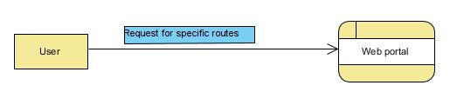

DFD-Level 1:

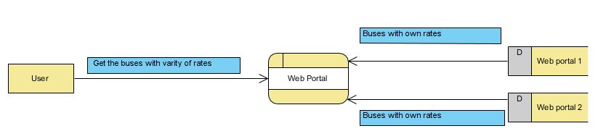

DFD-Level 2:

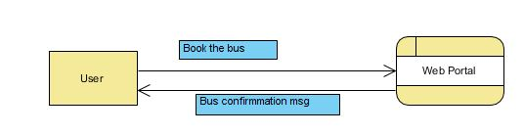

**6.2 Sequence Diagram**:

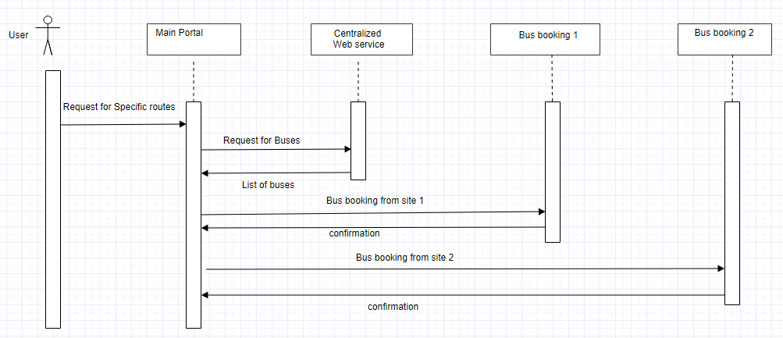

**6.3 Deployment Diagram**:

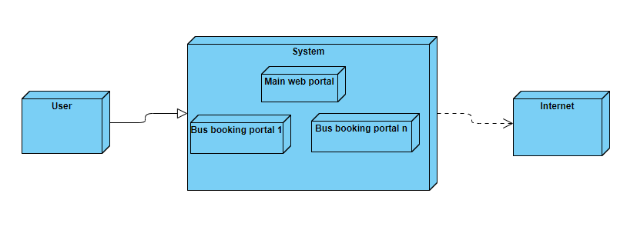

**6.4 Use Case Diagram**:

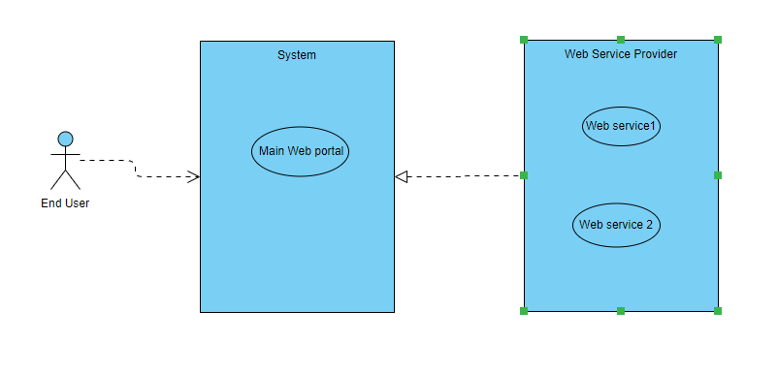

**6.5 Class Diagram**:

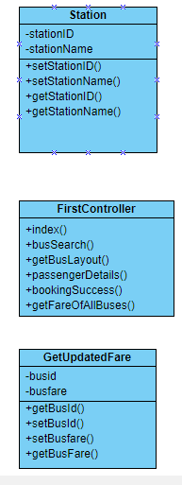 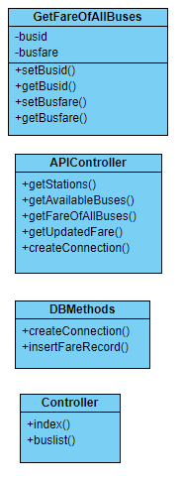

**6.6 System Architecture**:

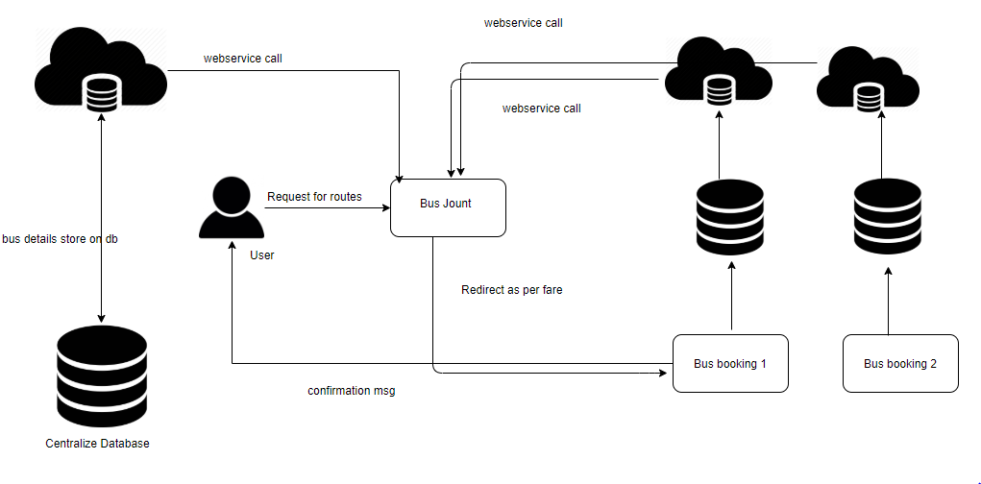

**Chapter 7**

**Test Case:**

|  |  |  |  |  |
| --- | --- | --- | --- | --- |
| **WBBCS** | **Project Name:** | Web Based Bus Compare System | **Test Designed by:** | Shubham Shinde |
|  | **Test Designed date:** | 29/7/2018 | **Test Execution date:** | 30/7/2018 |

|  |  |
| --- | --- |
| **Precondition** | Home Page Url ,Redirection From Home Page |
| **Dependencies:** | Internet connection ,web browser |

|  |  |  |  |  |  |  |
| --- | --- | --- | --- | --- | --- | --- |
| **Test Case ID** | **Test Title** | **Test Steps** | **Test Data** | **Expected Result** | **Actual**  **Result** | **Status** |
| TC1 | Check Home Page  URL | 1. Go to Browser | http://buswebservice-env1.s8gzuqmmjk.us-east2.elasticbeanstalk.com/ | User Should Get Home Page | As Expected | Pass |
|  |  | 2. Enter Home Page  Url |  |  |  |  |
|  |  | 3. Click Enter |  |  |  |  |
|  |  |  |  |  |  |  |
| TC2 | Check Home Page  UI | 1. Go to Browser | http://buswebservice-env1.s8gzuqmmjk.us-east2.elasticbeanstalk.com/ | User Should Get From,To,Date of Journey and Search Buses Button With Proper Size,Font and Shape | As Expected | Pass |
|  |  | 2. Enter Home Page  Url |  |  |  |  |
|  |  | 3. Click Enter |  |  |  |  |
|  |  |  |  |  |  |  |
| TC3 | Check FROM  Textbox Field | 1.Enter City Name | Pune | User Should Get Dropdownlist to Select Entered City | As Expected | Pass |
|  |  |  |  |  |  |  |
| TC4 | Check To Textbox  Field | 1.Enter City Name | Latur | User Should Get Dropdownlist to Select  Entered City | As Expected | Pass |
|  |  |  |  |  |  |  |
| TC5 | Check Date of  Journey Field | 1.Select Date From  Calendar |  | User Should Get Calendar To Select Date | As Expected | Pass |
| TC6 | Check Functionality  Search Buses Button | 1.Click Search Buses  Button |  | User Should Able to Click On Button | As Expected | Pass |
|  |  |  |  |  |  |  |
| TC7 | Check Functionality  Search Buses Button | 1.Keep From Field  Blank |  | User Should Able to Click On Button | As Expected | Pass |
|  |  | 2.Enter City In To  Field | Latur |  |  |  |
|  |  | 3.Select Date From  Calendar | 07-31-18 | User Should Get Alert At From Field with message "Please Fill Out This Field" | As Expected | Pass |
|  |  | 4.Click Search Buses  Button |  |  |  |  |
|  |  |  |  |  |  |  |
| TC8 | Check Functionality  Search Buses Button | 1.Enter City In From  Field | Pune | User Should Able to Click On Button | As Expected | Pass |
|  |  | 2.Keep To Field Blank |  |  |  |  |
|  |  | 3.Select Date From  Calendar | 07-31-18 | User Should Get Alert At To Field with message "Please Fill Out This Field" |  |  |
|  |  | 4.Click Search Buses  Button |  |  |  |  |
|  |  |  |  |  |  |  |
| TC9 | Check Functionality  Search Buses Button | 1.Enter City In From  Field | Pune | User Should Able to Click On Button | As Expected | Pass |
|  |  | 2.Enter City In To  Field | Latur |  |  |  |
|  |  | 3.Select Date From  Calendar | 07-31-18 | User Should Able to Select Date From  Calendar, |  |  |
|  |  | 4.Click Search Buses  Button |  | Selected Date Should Be Display at Same Field. |  |  |
|  |  |  |  |  |  |  |
| TC10 | Check Functionality  Search Buses Button | 1.Enter City In From  Field | Pune | User Should Able to Click On Button | As Expected | Pass |
|  |  | 2.Enter City In To  Field | Latur | User Should Redirect To Available Buses Page. |  |  |
|  |  | 3.Select Date From  Calendar | 07-31-18 |  |  |  |
|  |  | 4.Click Search Buses  Button |  |  |  |  |
|  |  |  |  |  |  |  |
|  |  |  |  |  |  |  |
| TC11 | Check Available Buses Page  UI | 1. Check UI |  | User Should Get Available Buses List With Details, and  View Seat Button With Proper Size,Font and Shape | As  Expected | Pass |
|  |  |  |  |  |  |  |
| TC12 | Check Functionality View  Seat Button | 1.Click View Seat  Button |  | User Should Able to Click On Button. | As  Expected | Pass |
| TC13 | Check Functionality View  Seat Button | 1.Click View Seat  Button |  | User Should Get Seat Layout For Selected. | As  Expected | Pass |
|  |  |  |  |  |  |  |
| TC14 | Check UI Of View Seat  Layout | 1.Click View Seat  Button |  | User Should Get Seat Boxes,Journey Details and Continue To Payment Button With Proper Size,Font and Shape | As  Expected | Pass |
|  |  |  |  |  |  |  |
| TC15 | Check Functionality View  Seat Layout | 1.Click View Seat  Button |  | User Should Get Journey Details On Layout. | As  Expected | Pass |
|  |  | 2.Select Seat |  | After Selecting Seat Box Color Change to Green. |  |  |
|  |  |  |  | Fare Should Change Accoring to Seat Selection. |  |  |
|  |  |  |  | Already Booked Seat box In Gray Color. |  |  |
|  |  |  |  | User Should Not Able to Select Already Booked Seat. |  |  |
|  |  |  |  |  |  |  |
| TC16 | Check Functionality Continue  To Payment Button | 1.Click Continue To  Payment Button | 1.Select Seat | User Should Able to Click On Button | As  Expected | Pass |
|  |  |  |  |  |  |  |
| TC17 | Check Functionality Continue  To Payment Button | 1.Select Seat | 1.Select Seat | User Should Redirect To Passenger Details Page | As  Expected | Pass |
|  |  | 2.Click Continue To  Payment Button |  |  |  |  |
|  |  |  |  |  |  |  |
| TC18 | Check Bus List Page UI | 1. Check UI | NA | User Should Get Available Buses List With Details, and two hyper link to choose Web Portal With Proper Size,Font and Shape | As  Expected | Pass |
|  |  |  |  |  |  |  |
| TC19 | Check Functionality Hyperlink 1,Web Portal | 1.Click On Hyperlink 1 | NA | User Should Get Redirect To Web Portal 1. | As  Expected | Pass |
|  |  |  |  |  |  |  |
| TC20 | Check Functionality Hyperlink 2,Web Portal | 1.Click On Hyperlink 2 | NA | User Should Get Redirect To Web Portal 2. | As  Expected | Pass |

**Screenshots:**

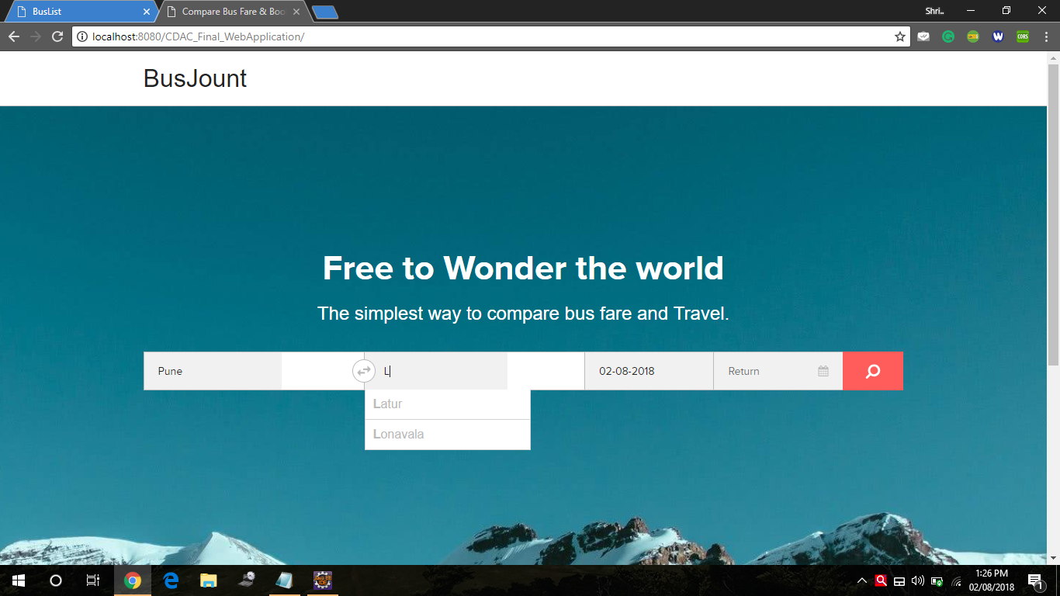

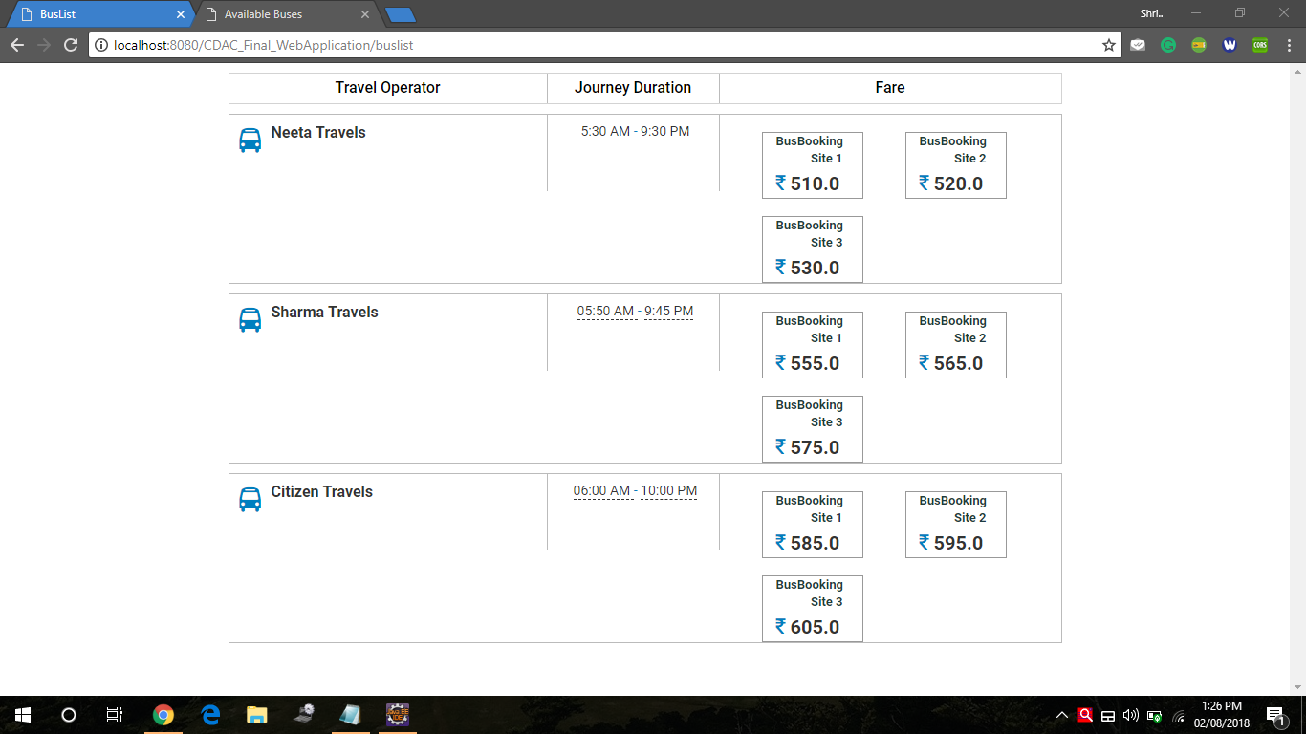

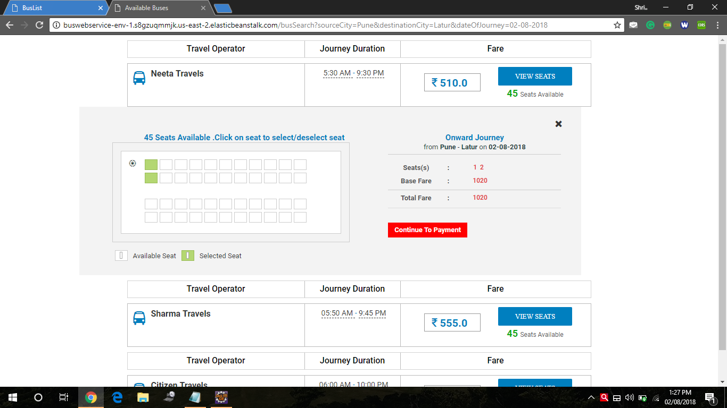

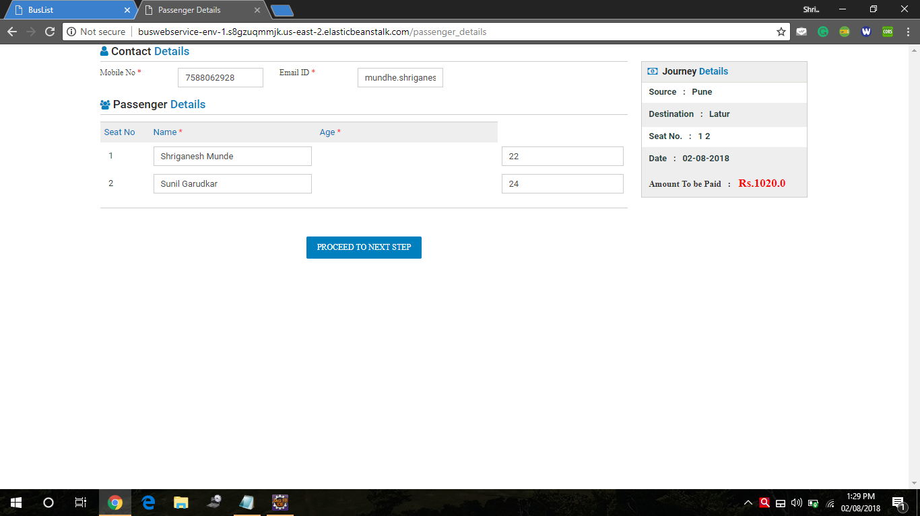

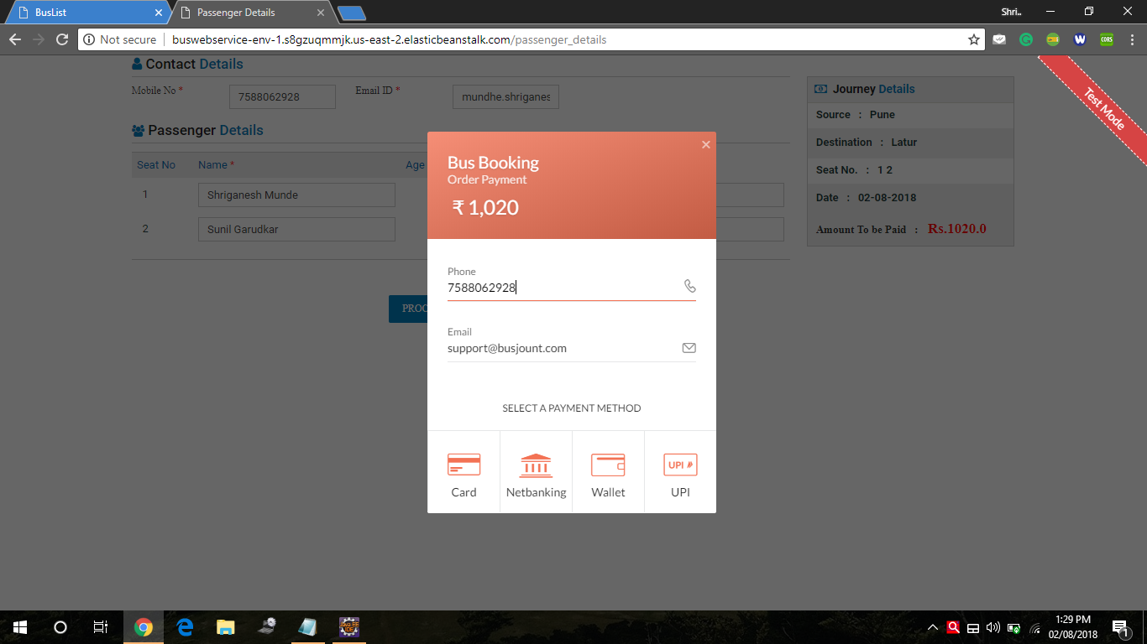

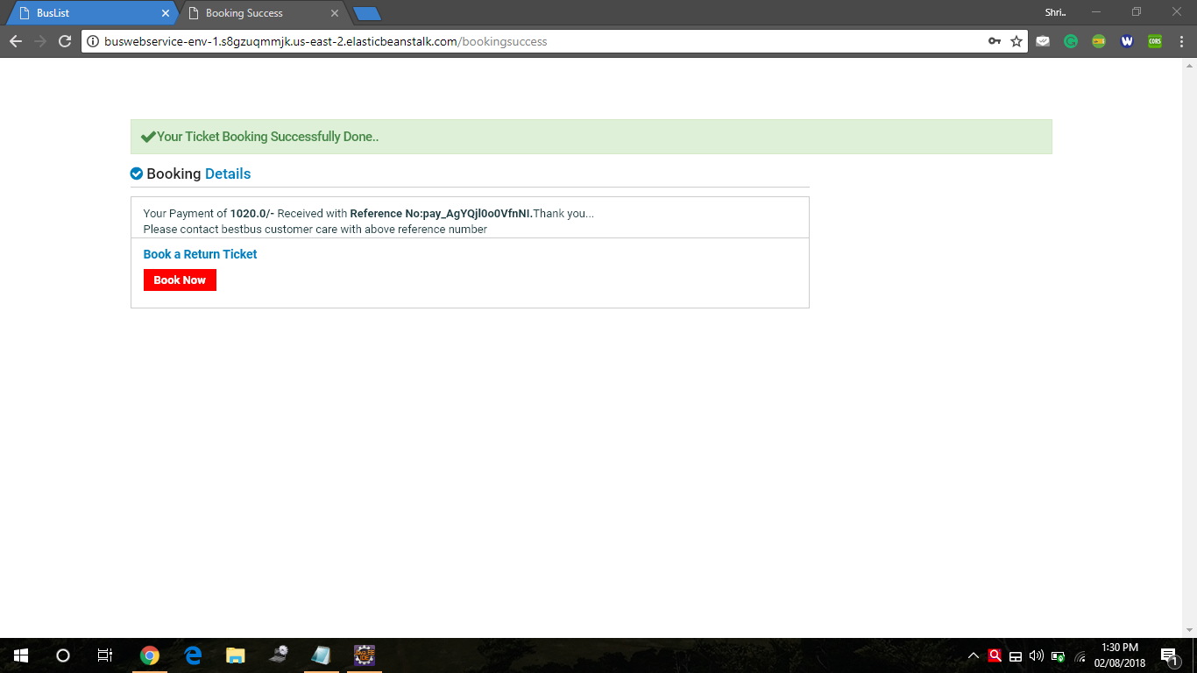

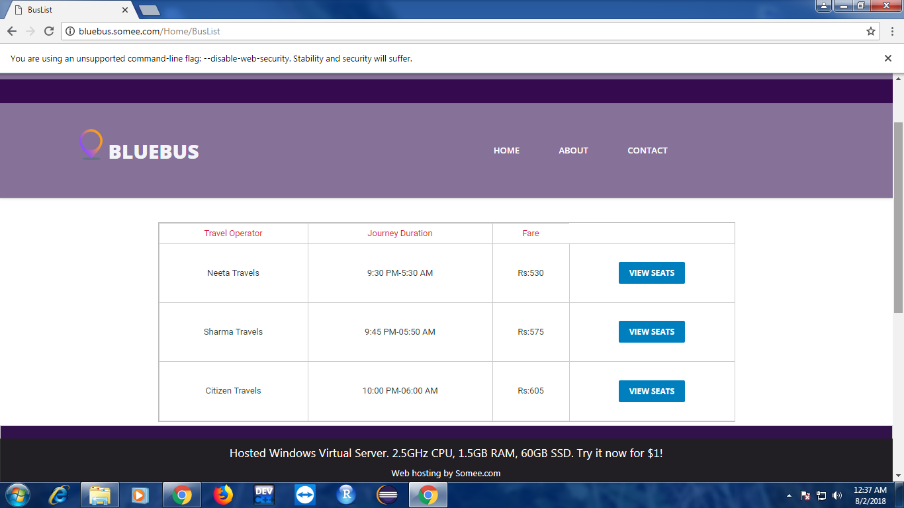

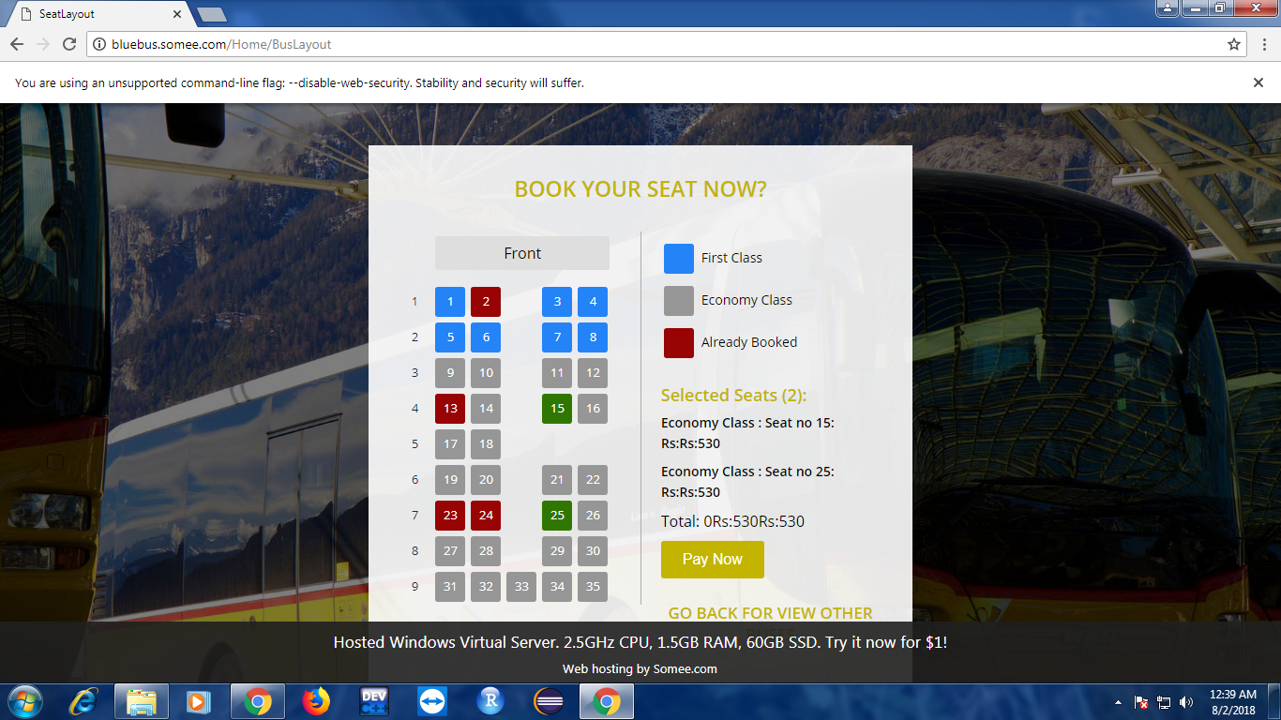

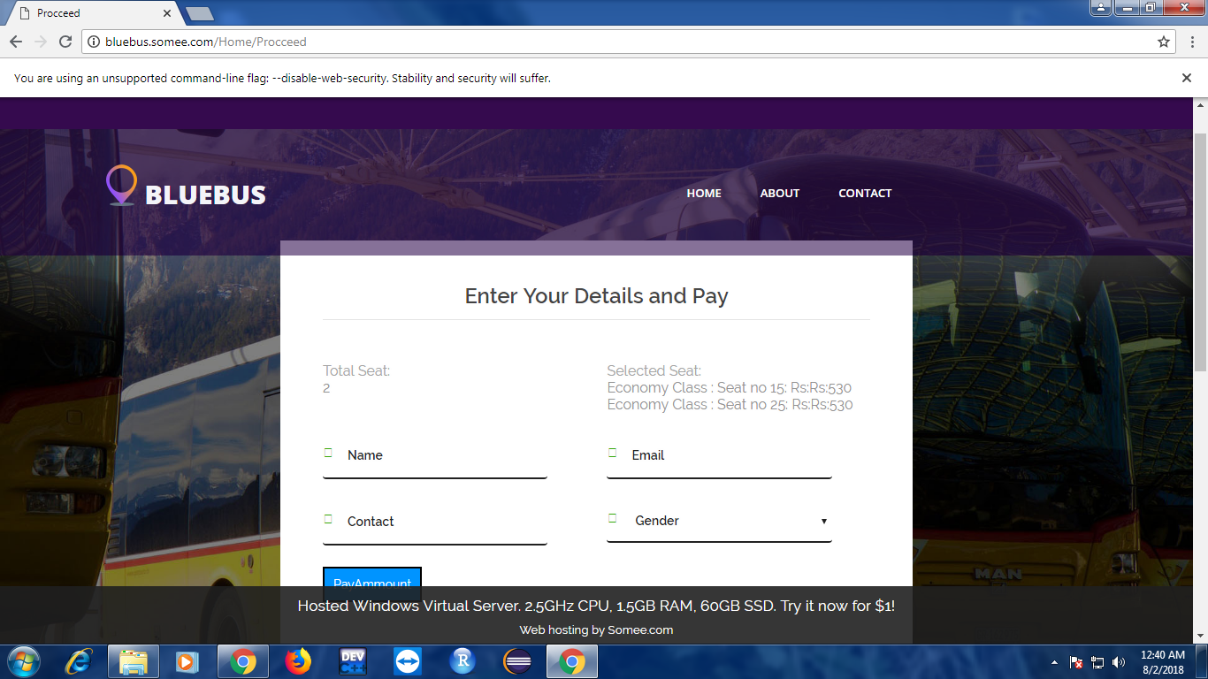

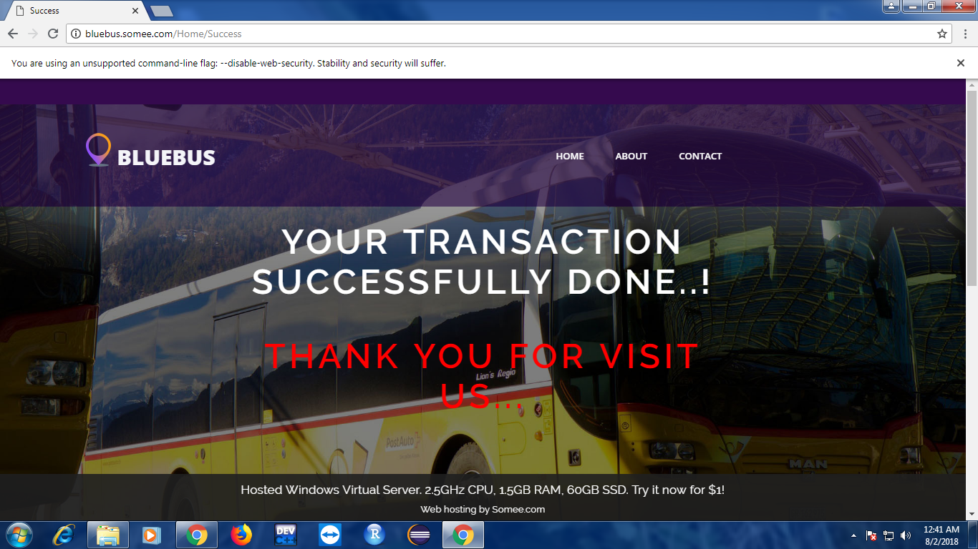

**10 References**

1. [https://www.trivago.in](http://www.trivago.in/)
2. <https://www.redbus.in>
3. <https://spring.io>
4. Mezghani, M. (2008). Study on Electronic Ticketing in Public Transport. Available at: http://www.emta.com/IMG/pdf/EMTA-Ticketing.pdf Accessed: 16th November 2014
5. Shivaji. Varma. (2010). Bus reservation system. Retrieved from http://shivajivarma.wordpress.com/2010/09/20/dbms-project-bus-reservation Accessed 19th November 2014